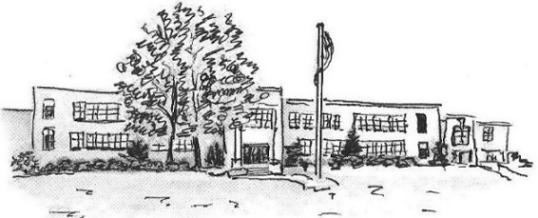
CHATTANOOGA SCHOOL FOR THE LIBERAL ARTS
Office of Admissions
6579 East Brainerd Rd. Chattanooga, TN 37421
423.855.2614 | csla_admissions@hcde.org

Application for 1st- 6th Grades 2018-19
Student Information
Name: _______________________________________________________ Name Student Goes By: _________________
First Middle Last
Street Address: ________________________________________ City: ___________________ Zip Code: ____________
Date of Birth: ____ /____ /____ Gender: ____ Male ____ Female Race: _______________
Current School: __________________________________ Grade 2017-18: ________
Hamilton County school student is zoned for (if different than above): _________________________________________
Parent/Guardian Information
Mother/Guardian Name: __________________________________________
Cell Phone: (_____) _______-___________ Email Address: ________________________________________
Address (if different than student): _______________________________________________________________
Employer: _______________________________ Work Phone: (_____) _________-____________
Father/Guardian Name: ___________________________________________
Cell Phone: (_____) _______-___________ Email Address: _________________________________________
Address (if different than student): ________________________________________________________________
Employer: _______________________________ Work Phone: (______) _________-____________
Student Lives with: _____ Parents _____ Mother _____ Father _____ Legal Guardian
Student has a sibling CURRENTLY enrolled at CSLA: ____ Yes ____ No If yes, name: ________________________

Parent/Guardian Acknowledgements
- I understand that if my student enrolls at CSLA, I will be required to attend two parent conferences, volunteer a minimum of 18 hours, and adhere to the HCDE Magnet School requirements each year. Failure to meet these requirements is grounds for loss of the seat at CSLA and at other HCDE Magnet Schools.
- I understand all CSLA students are given high academic expectations, take a foreign language and participate in various field learning experiences. I can learn about the Paideia Philosophy at www.csla.hcde.org.
- I understand that if my student is not offered admission, I will receive an email with instructions about how to keep my application active each year in mid-January. I am responsible for notifying CSLA of any changes in contact information such as address, email or phone number.
- Students are added to the wait list by the date the application is received. You may mail, email or return this application in person to CSLA. Please contact CSAS at www.hcde.csas.org for an application to their school.
Parent/Guardian Signature: _________________________________________________ Date: __________________
Application received on __________________ at _________________ by __________________
Admission Status: ___A ___ DC ___RM Date: _____________ Reason: ________________________

