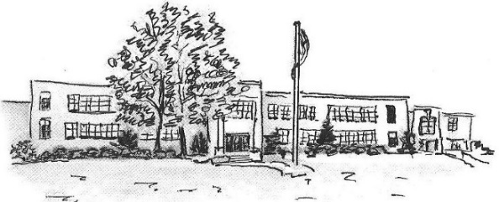
CHATTANOOGA SCHOOL FOR THE LIBERAL ARTS
Office of Admissions
6579 East Brainerd Rd. Chattanooga, TN 37421
423.855.2614 | csla_admissions@hcde.org

Kindergarten Sibling Identification Form
2019-20

ELIGIBLE SIBLINGS INCLUDE a brother or sister, half-brother or half-sister, step-brother or step-sister of a student currently enrolled in grades K-7 at CSLA who reside at the same address of the currently enrolled student. This does NOT include aunts, uncles, cousins, nieces, nephews, etc. In cases involving joint custody, legal documentation is required. Proof of sibling status may be requested.

Siblings must be 5 years old on or before August 15, 2019 to apply for Kindergarten 2019-20.

A parent or legal guardian must complete the three required elements of the application process this fall to be offered a seat:

- Attend an Orientation Meeting on either Sept. 13th or Sept. 25th at 6pm (sign-up at csla.hcde.org)
- Attend a School Tour on either Oct. 18th or Oct. 23rd at 9:30am or 10:30am (sign-ups will be done electronically)
- Attend a Seminar on either Nov. 1st or Nov. 12th at 6pm (sign-ups will be done electronically)

Additional paperwork deadlines and attendance at Kindergarten Shadow Day and Kindergarten Parent Night will also be required in the second semester to secure a spot for Kindergarten 2019-20.
Please complete and return this form no later than Friday, Sept. 7, 2018.

Current Student Name: ____________________________________________________ Grade: _________

Incoming Kindergarten Student Name: _____________________________________________________

Date of Birth: _____ /_____ /______ Address: _________________________________________________

_________________________________________________

Student lives with: ____ Parents ____ Mother ____ Father ____ Legal Guardian

Mother/Guardian Name: _____________________________________________ Phone: _____________________

Father/Guardian Name: ______________________________________________ Phone: _____________________

